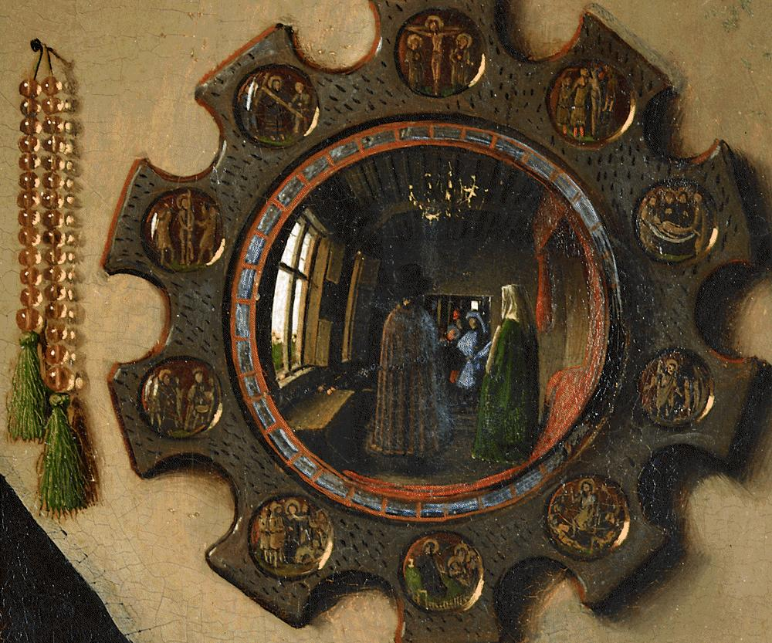
Art and Culture

Art 151-2 (2018)
222 McWethy Hall
Christina Morris Penn-Goetsch (fka McOmber)
Classes meet 10-11 am and 1-3 pm
Office: 214 McWethy /Office Phone: 895-4137
Office Hours: Thurs. 3:00 to 4:00 pm
And by appointment (I am often on-campus until early evening)
cpenngoetsch@cornellcollege.edu
Slide Room: 206 McWethy Office Phone: 895-4346
Home: 319 338-7438
Detail of mirror, Jan van Eyck, Arnolfini Portrait, 1434
“Art is the lie that makes us realize the truth.” --Pablo Picasso

Introduction and Objectives

This course provides a historical survey of the visual arts in the Western world (1400-1900), with a focus on the development of the concept of the modern artist and the evolving definition of art in the West. As part of this process, the course introduces students to basic methods used by art historians. At its core, the field or discipline is interested in the form and subject matter within a particular historical context. We will explore this relationship by examining a few key works in class that function as models for research projects. One of our other goals will be to learn an appropriate vocabulary for describing images and architecture. But the last goal is related to how art historians approach the visual arts. Usually we analyze works of art in light of other related examples from the same or different cultural groups. This is called the compare and contrast method and will encourage a familiarity with how to identify a large body of images. Christina Penn-Goetsch, Professor of Art History, will lead most of the classroom lectures and participate in workshops.

Because this is an introductory writing course, an additional portion of our time will be spent developing related skills. Jennifer Ferrell, Writing Consultant and Coordinator for Writing Courses, will assist in this process by conducting workshops and making herself available to you for advice. She can help you formulate questions and refine your written presentation (317 Cole Library, 895-4812, jferrell@cornellcollege.edu). If you have particular concerns about your writing or reading skills, please let her know as soon as possible.

Research plays a critical role for this course; therefore, the other professor for this course is librarian Gregory Cotton (303 Cole Library, 895-4454, gcotton@cornellcollege.edu). He will present workshops about research methods on library and web research. You should schedule an appointment to discuss locating sources. All of the instructors for this course are adept at reviewing papers and sharing ideas about how to construct an argument. We are used to teaching within and outside the classroom.

College Learning Objectives

This course addresses the Education Priorities of Cornell College with particular foci on the following outcomes:

- Students will gain proficiency in analyzing or “reading” visual imagery provided in the visual arts as well as how imagery, in general, informs how we perceive gender, race, class, and religion in the Western art of Europe. This proficiency will be developed through the close examination of imagery in group discussion and written assignments according to the professional standards and style of the discipline of art history (Communication, Reasoning, and Intercultural Literacy).
- Art history courses integrate the recognition of particular objects as a reflection of individual cultures and time periods. This course will therefore expect that students will be able to recognize how such images have been discussed by scholars as well as their methodologies and be able to employ information literacy tools in order to assist in this process. (Knowledge, Inquiry, and Intercultural Literacy).

Textbooks

Hacker, Diana and Nancy Sommers. A Pocket Style Manual. 7th ed., Boston: Bedford/Saint Martin’s, 2015 (You could also use the 6th edition).

On reserve in Cole Library, you will find a few art history survey textbooks (An earlier edition of Gardner’s Art through the Ages and Janson’s Art History). These books will allow you to review the images in a broader historical context on a regular basis as a supplement to class discussion. A study sheet is usually offered each day that the class meets, in order to assist you with taking notes.

Additional Accommodations

Students who need accommodations for learning disabilities must provide documentation from a professional qualified to diagnose learning disabilities. For more information see
cornellcollege.edu/disabilities/documentation/index.shtml

Students requesting services may schedule a meeting with the disabilities services coordinator as early as possible to discuss their needs and develop an individualized accommodation plan. Ideally, this meeting would take place well before the start of classes.

At the beginning of each course, the student must notify the instructor within the first three days of the term of any accommodations needed for the duration of the course.

Course Requirements

Your grade will be based on the following assignments:

Week 1-2

Assignment A (15%), Due Saturday, Sept. 29, 12:00 noon: This assignment focuses on the iconography or subject matter of a work of art. Each writer considers the possible meaning and/or symbolism found in the Arnolfini Portrait and the social context. Read the articles and excerpts, dating from 1934 to 2003, and incorporate references to at least five of them in your essay. Although you only need to cite five sources in your text, I would encourage you to consider how you might address portions of most of the articles in the discussion of a single theme. Include Panofsky’s article from 1934 and Carroll’s presentation from 1993. These two articles will provide you with a sense of how approaches to the very same work of art have changed over time. The study of these differences is called historiography.

Make sure to begin your double-spaced, five-page essay with a clear thesis statement (A thesis is not the same as a topic. You must assert a particular view based on the written sources and the painting.). Defend the thesis with specific examples from your readings that are part of paragraphs that begin with a topic sentence. Your opinion must be based on the assigned material that you have read. Format the paper according to the MLA style guidelines included in the Hacker text. You may also search for MLA style information at https://owl.english.purdue.edu/owl/resource/717/01/

Include internal citations and a works cited page with your paper.

Sources
(The following citations follow the Chicago Manual of Style format)

Bedaux, Jan Baptist. “Reality of Symbols: The Question of Disguised Symbolism in Jan van Eyck’s Arnolfini Portrait.” Simiolus, 16 (1986): 5-26. (Available on JSTOR) Article in a Journal*

Campbell, Lorne. “Jan van Eyck” in The Fifteenth Century Netherlandish Schools. Reprint Edition, 174-211. London: National Gallery, 1998. (Available in Cole Library—Reserves 759.9492 C1531f 2000) Book with one author

Carroll, Margaret. “In the Name of God and Profit: Jan van Eyck’s Arnolfini Portrait.” Representations 44 (1993): 96-132. (Available on JSTOR) Article in a Journal
Hall, Edwin. The Arnolfini Betrothal: Medieval Marriage and the Enigma of Van Eyck’s Double Portrait. Berkeley: University of California Press, 1994. University of California edition. (Available in Cole Library Reserves--759.9493 Ey22h 1994 or as an ebook) Book with one author in print or ebook

Harbison, Craig. “Sexuality and Social Standing in Jan van Eyck’s Arnolfini Double Portrait.” Renaissance Quarterly 43 (1990): 249-91. (Available on JSTOR)
Article in a Journal

Jardine, Lisa. “Prologue to Worldly Goods.” In Critical Perspectives on Art History. Eds. J.C. McEnroe and D.F. Pokinski, 90-91. Upper Saddle, New Jersey: Prentice Hall, 2002. (Available on Reserve--709 C869m 2002) Chapter from an Anthology

Koster, Margaret. “Arnolfini Double Portrait: A Simple Solution.” Apollo Magazine 157 (2003): 3-14. Article located on Moodle, as I had to use interlibrary loan to access the article.

Panofsky, Erwin. “Jan van Eyck’s Arnolfini Portrait.” Burlington Magazine 64 (1934): 117-27. (Available on JSTOR) Article in a Journal

Snyder, James. “Jan van Eyck and Adam’s Apple.” Art Bulletin 58 (1976): 511-15.
(Available on EBSCO Art Source and JSTOR) Article in a Journal

*The purple text is just intended to help you identify the type of source. It does not reflect what the Chicago Style requires for a citation. Do not include this particular information with your “Works Cited” page.

There are some unusual features related to art history papers. Titles for works of art must be underlined or placed in italics. Do not use quotation marks. Also, one must attach photocopies or scanned images of the works discussed to the back of each paper. Make sure that you use only one image per page and include your own typed caption with artist, title, medium, and date. When you make reference to an image in the body of your text, place the figure number within parentheses before the punctuation mark (Fig. 1). The figure pages should be at the very end of the paper. Beneath the scanned image you should list the artist, title, and date.

One hard copy of the paper should be provided to Christina Penn-Goetsch and an attachment of the same paper sent to cpenngoetsch@cornellcollege.edu, jferrell@cornellcollege.edu, and gcotton@cornellcollege.edu.

Students often wonder about when to cite sources with parenthetical notations, footnotes, or endnotes. This concern is justified, as plagiarism is a serious offense. I reserve the right to fail any paper, even if the plagiarism is due to carelessness alone. The original source of the word implies the stealing of slaves or children, but we are talking about the stealing of ideas in an academic context. You may want to check out http://owl.english.purdue.edu/handouts/research/r_plagiar.thml. There are three primary areas that should include some form of a citation.

- If you use the exact words of an author, use a citation. Place the words within quotation marks.
- If you draw upon the ideas, arguments, or observations of others, use citations.
- If you include facts not widely available or known, use citations.

Some scholars also use a citation, when they want to direct the reader toward useful information on a given subject or to explain an argument further. As you cite sources, make sure to go to the original source for an idea whenever possible. For example, do not cite Harbison or Carroll for the ideas first argued by Panofsky. If you follow these guidelines, you will be well prepared for future research projects.

Cornell College expects all members of the Cornell community to act with academic integrity. An important aspect of academic integrity is respecting the work of others. A student is expected to explicitly acknowledge ideas, claims, observations, or data of others, unless generally known. When a piece of work is submitted for credit, a student is asserting that the submission is her or his work unless there is a citation of a specific source. If there is no appropriate acknowledgement of sources, whether intended or not, this may constitute a violation of the College’s requirement for honesty in academic work and may be treated as a case of academic dishonesty. The procedures regarding how the College deals with cases of academic dishonesty appear in The Compass, our student handbook, under the heading “Academic Policies – Honesty in Academic Work.”

Week 2-3

Meet with Librarian Greg Cotton: Professor Greg Cotton will meet with the class on Sept. 1, as well as Oct 1 and 8 to discuss the research process in art history. You will be responsible for answering a series of questions about your own research for the major paper assignment for this course. One of them will grade this assignment and give you personalized attention in finding the best material possible. Remember that your final research paper should include eight to ten sources with references to books and articles. These should include primary and secondary sources whenever possible; however, you should avoid using tertiary sources like encyclopedias (e.g. Oxford Art or Wikipedia) or dictionaries, textbooks, on-line textbooks (e.g. Khan Academy and Smart History) as well as popular magazines, travel guides, and blogs.

Assignment B (10%), Friday, Oct., 5 at 5 pm: This essay eventually will become part of an eight- to ten-page research paper; therefore, you will want to choose a topic with which you are fascinated. The assignment requires that you compose a three to four-page essay about the overall appearance of a single work of art without citing other research. You must employ a formal analysis (This type of analysis considers color, line brush stroke, medium, light, and possibly style). You should not be addressing the subject matter (iconography) or contextual meaning (iconology) of the work, based on a story illustrated or any sort of symbolism that is not readily apparent without research. We did a formal analysis of the Arnolfini Portrait on the first day of class. Remember how we could see some aspects about the painting without even doing research? This is what you are doing.

Your paper should answer the question, “What does it look like?” Describe how the image or structure appears. Do not panic, because even a formal analysis allows you to consider stylistic similarities with other works of art. In other words, you may compare the form or style to that of other works of art. At the same time, you should start completing research right away. Although you may not choose to have any citations for this paper, you should know something about the subject matter and the future direction of your next paper. The next paper is a research paper on the very same topic. You should attach a working bibliography of the sources you will use for the next two assignments and figures to the end of this paper.

The best place to begin thinking about your research paper is by looking at your textbook. General texts often introduce you to some of the questions and controversies that may be of interest. This and related reference sources have useful bibliographies and notes that will direct you toward other material. In most cases, you will include periodical literature and books in your bibliography. Consider the holdings of the Cole Library and those articles included on EBSCO in Art Index and JSTOR. Although there is no set number of required sources for the assignment, your paper should investigate a wide range of materials. Avoid using your textbook or an encyclopedia as a source. It may be a great reference guide, but it is too general to be used as a bibliographic source for your research project. We will meet with the librarian Greg Cotton to discuss how to begin your research project in class on Monday, October 9 and Wednesday, October 18, but an individual appointment also will required. Your final research paper should include at least ten strong sources with references to books and articles. Pay attention to which scholarly sources are most respected by others.

The instructions for Assignment A apply here as well, except for one requirement. Instead of using MLA style guidelines, I would like for you to use those listed in the Chicago Manual of Style as guidelines for Assignments B-D. This time, you will not have a “Works Cited” page. Your paper, however, will have a bibliography of all strong works consulted or examined for this paper. Do not limit yourself to sources cited in this bibliography. The format appears in the Hacker text or on-line from the Cole Library Writing Studio website: https://owl.english.purdue.edu/owl/resource/717/01/

A hard copy of the second paper should be provided to the professor and an attachment of the same paper sent to cpenngoetsch@cornellcollege.edu, jferrell@cornellcollege.edu, and gcotton@cornellcollege.edu.

Week 3-4

Assignment C (15%), Due Friday, Oct. 12, 5 pm: This five to seven-page paper finally addresses the content or iconography of a single work of art. For this paper, you should avoid discussions of the style and medium. You may want to compare the work to those of others using the same subject matter or theme. This is the moment where you introduce your ideas about the meaning or purpose behind the work. Your paper will answer the question, “What does it represent?” Place the work within the context in which it was produced. Do not forget to privilege primary sources over secondary ones. Avoid lengthy quotes from secondary sources. Follow the guidelines that you employed for Assignment B. Omit biographical material unless directly relevant to your thesis. More often than not, this information is not necessary and detracts from the focus of your argument. Do not forget to cite your sources with endnotes or footnotes!

A hard copy of the third paper should be provided to the professor and an attachment of the same paper sent to cpenngoetsch@cornellcollege.edu, jferrell@cornellcollege.edu and gcotton@cornellcollege.edu.

Assignment D (25%), Due Wednesday, Oct. 17 at 5 pm (you can submit the paper earlier): This double-spaced, eight to ten-page paper combines Assignments B and C under a single thesis that includes an introduction that maps out the relationship between the topics of your earlier papers that addressed style and iconography (form and content). This means that you will revise both essays as part of this larger and more complex research project. You’ll need to write a new introduction, draw stronger connections between the two parts of the paper, and write a new conclusion. The paper should begin with a description of the work. Your goal will be to demonstrate how style and iconography are interrelated. In other words, the question you will be answering with this paper is “Why does it look the way it does?” The two approaches, when combined, will lead the viewer/reader toward a greater understanding of the object under consideration.

Your completed paper will consist of four parts in the following sequence: text with footnotes OR text plus the endnotes, bibliography, and illustrations. You may use a title page if you so desire, but avoid the use of binders or folders. A simple paper clip or staple is adequate. The photocopies or scanned images should have new figure numbers and captions. Number each page consecutively.

A hard copy of the fourth paper should be provided to the professor and an attachment of the same paper sent to cpenngoetsch@cornellcollege.edu, jferrell@cornellcollege.edu, and gcotton@cornellcollege.edu.

Additional Assignments:

Exams (10% and 10%), Due Wednesday, Oct. 3 and Monday, Oct. 15: The short exams will involve employing terms, identifying slides, and comparison essays. Learning to recognize styles and completing visual analyses may be new to you. Regular review of the material will prove more helpful than last minute cramming. Review slides/images will be found on flashcards uploaded to Moodle on a weekly basis unless an exam comes up sooner. Although you will have a great deal of information to process, class lectures and handouts will provide you with guidelines. The art history survey texts on reserve in Cole Library may assist you, but exams will focus on specific images, sculptures or structures discussed in class.

Wednesday, Oct. 17: Review and Art History Charades! This rather fun assignment and it will be our last celebration of our time together.

Attendance and Participation (15%): Attendance is critical to your success, because we discuss more than what is included textbook in class. If you have regular attendance, you can expect a “C” for this portion of your grade. Involvement in class discussion can increase your grade, just as poor attendance can decrease your overall grade. Participation allows you and your colleagues to be more actively engaged in the process of learning. If you must miss a class lecture, contact me as soon as possible. It is impolite or rude not to tell a faculty member why you were or will not be in class. Borrow notes from other class members.

Topics and Required Readings--Tentative
(The following information will assist you in focusing on appropriate topics/artists, when you are completing reading assignments. Assignments are usually due on the day listed.)

Class Hours: typically 10-11 am and 1-3 pm

Sept. 24 Introduction (Starts at 10:00 am)
Giotto
Gardner’s “What is Art History” (Moodle)

Read Carroll Article: Carroll, Margaret. “In the Name of God and Profit: Jan van Eyck’s Arnolfini Portrait.” Representations 44 (1993): 96-132. (Available on JSTOR) Article in a Journal. Currently linked to the course Moodle page.

Sept. 25 Early Renaissance—Flanders
The Limbourg Brothers

Read Panofsky Article: Panofsky, Erwin. “Jan van Eyck’s Arnolfini Portrait.” Burlington Magazine 64 (1934): 117-27. (Available on JSTOR) Article in a Journal. I will provide you with a useful handout in class and we will discuss the three questions in class tomorrow.

Sept. 26 Renaissance—more Flanders
(morning class starts at 10:15 am)
Robert Campin and Jan van Eyck
Articles, Wall Street Journal and New York Times (in class)

Answer the following question: How might you use the Snyder and Jardine text in an argument about the Arnolfini Portrait?

Jardine, Lisa. “Prologue to Worldly Goods.” In Critical Perspectives on Art History. Eds. J.C. McEnroe and D.F. Pokinski, 90-91. Upper Saddle, New Jersey: Prentice Hall, 2002. (Available on Moodle and on reserve--709 C869m 2002) Chapter from an Anthology.

Snyder, James. “Jan van Eyck and Adam’s Apple.” Art Bulletin 58 (1976): 511-15.
(Available on EBSCO Art Source and JSTOR) Article in a Journal. Go to the Cole Library database.

Sept. 27 Renaissance—Germany
Dürer
Article: Scientific American (in class)

Sept. 28 Renaissance--Italy
Donatello
Excerpt: Marilyn Stokstad, Art History (textbook) (in class)
Assignment A Due—12 noon on Saturday, Sept. 29

Oct. 1 Renaissance in Italy
Leonardo and Michelangelo
Chapter: Dan Brown, The Da Vinci Code (fiction) (in class)

Oct. 2 Renaissance to Baroque in Italy
Titian, Veronese, and Caravaggio Artemisia Gentileschi

Oct. 3 Quiz—10:00-11:30 am
Artemisia Gentileschi

Oct. 4 Baroque in the Netherlands
(afternoon class starts at 1:15 pm)
Bernini and Velázquez

Oct. 5 Baroque in the Netherlands
Dutch Still Life
Assignment B Due—5 pm

Oct. 8 Rococo and Neoclassicism
Watteau, Fragonard, and David

Oct. 9 Neoclassicism and Romanticism
Goya and Turner

Oct. 10 Realism
Courbet

Oct. 11 Realism and Impressionism
Courbet and Manet

Oct. 12 Impressionism
Degas and Monet
Assignment C Due—5 pm

Oct. 15 Quiz—10:00-11:30 am
Putting together Assignment D 1:00-3:00 pm

Oct. 16 Not a Standard Class Day—Writing Day/Conference Day
Revise Final Paper and meet with Penn-Goetsch and/or Ferrell

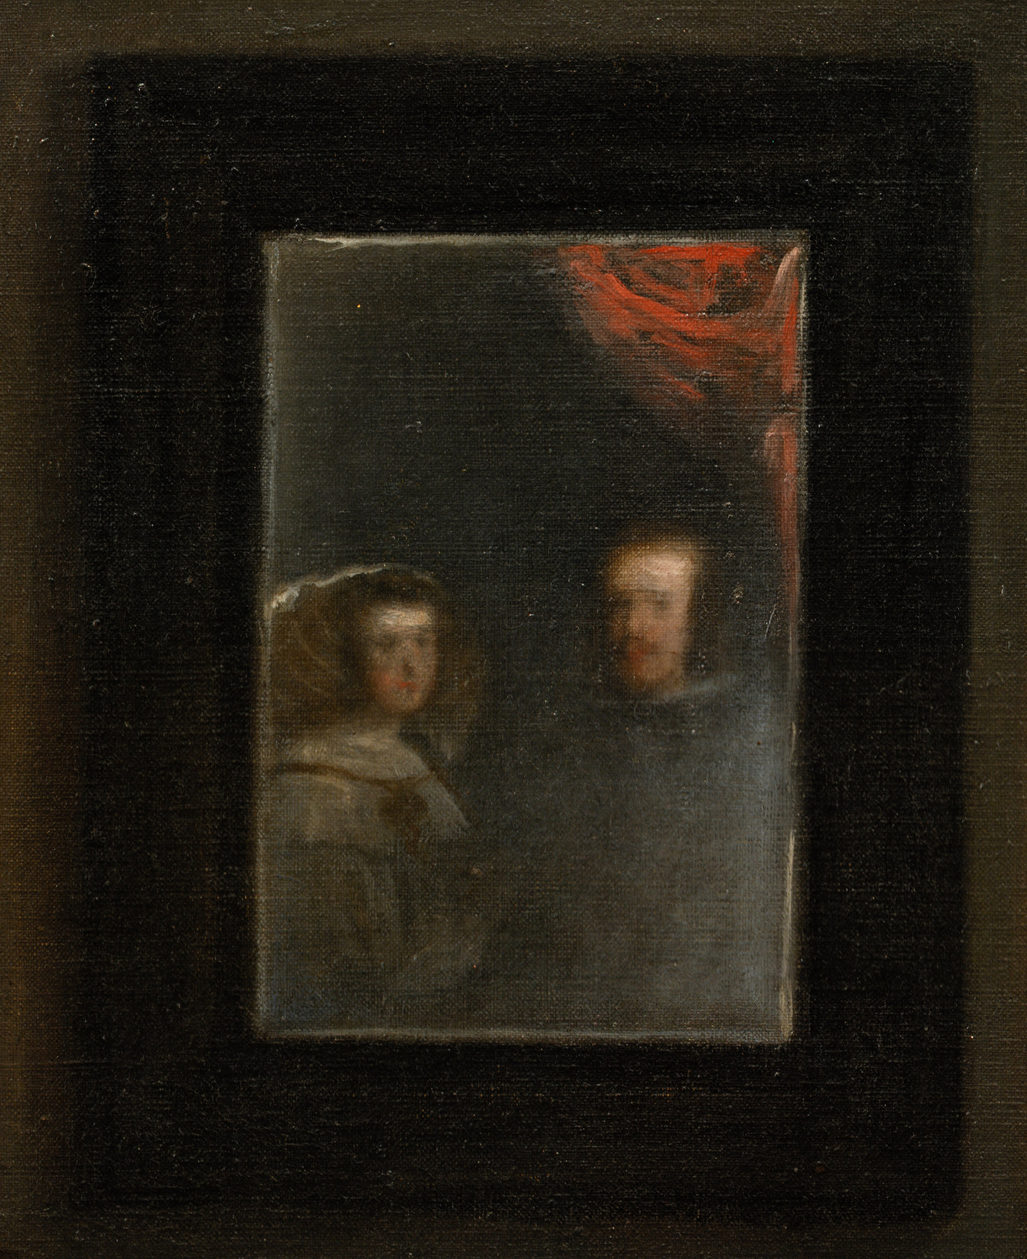
Oct. 17 Charades at 10 am
Detail of mirror from Velazquez, Maids of Honor, 1656
Figure 1 Detail, Velázquez, Maids of Honor, 1656
Final Paper (Assignment D) Due—5pm
Detail, Diego Velázquez - Las Meninas, 1656.

